Boston Scientific Peripheral Interventions
TheraSphere 360 Digital Platform Device Software Architecture
XXXX, Rev AA

1. Introduction 3
1.1. Purpose 3
1.2. Scope 3
The TheraSphere 360 project is being executed as a PDP project (Project Number: 2361, SAP: 212920). 3
This plan is an overarching document that supports the microm and its component parts. This document will outline the architecture for the system and components as they break down between SaMD and Non-SaMD. 3
This plan will be approved and circulated to team members prior to Design Inputs review, and after any updates required throughout the project. 3
1.3. Definitions, Acronyms, and Abbreviations 3
1.3.1. ACRONYMS 3
1.4. Applicable Documents 4
1.5. Overview 4
2. Architectural Representation 5
2.1 TheraSphere Platform Architecture 5
2.1.1. Introduction 5
2.1.2. TO-DO 5
2.2. AEM Application Architecture 6
2.2.1. Application Architecture Overview 6
2.3. AEM cloud Internal Architecture 7
2.4. Securing API 8
2.4.1. AEM - API Gateway (TOP/Microservices) – CIO Sequence Diagram 8
2.5. SaMD Application 9
2.6. AEM - SaMD Integration 9
2.7. AEM - CIP (Customer Identity Portal) Integration 10
2.8. AEM - Tableau Integration (Data) 12
2.9. AEM - Resource Module (Contact US/FAQ Pages) 14
Architectural Goals and constraints 14
Use case View 14
Software Of Unknown Provenance (SOUP) Usage 14
Logical View 14
Process View 15
Deployment View 15
2.10. AEM Code Branching & Deployment 15
2.10.1. Code Propagation Path 15
2.10.2. Deployment Pipelines 15
2.10.3. Branching 16
Implementation View 17
Data View 18
Design Constraints 18
Security Architecture 18
Security Controls 19
Security Architecture Views 19
Appendices 21

List of Tables
Table 1 Applicable Documents (Internal) 3
Table 2 Applicable Documents (External) 3
Table 3 External Standards 3

Introduction
The introduction of the Device Software Architecture document provides an overview of the entire document. It includes the purpose, scope, definitions, acronyms, abbreviations, references, and overview of this Device Software Architecture document.

Purpose
The purpose of this document is to define the TheraSphere 360 portal Software Architecture.
This document describes the architecture for the overall TheraSphere 360 portal application as well as its embedded components and interfaces.

Scope

The TheraSphere 360 project is being executed as a PDP project (Project Number: 2361, SAP: 212920).

This plan is an overarching document that supports the microm and its component parts. This document will outline the architecture for the system and components as they break down between SaMD and Non-SaMD.

This plan will be approved and circulated to team members prior to Design Inputs review, and after any updates required throughout the project.

Definitions, Acronyms, and Abbreviations

ACRONYMS
The following Acronyms, Abbreviations & Definitions are used in this document:
Term | Definition
CN | Change Notice
D&D | Design and Development
WC | Windchill
SDP | Software Development Plan
SRS | Software Requirements Specification
DHF | Design History File
R&D | Research and Development
SW | Software
GPSV | General Principles of Software Validation (FDA)
SAMD | Software as Medical Device
SOUP | Software of Unknown Provenance
OTS | Off- the-shelf software
TLD | Top level design
TES | Test Environment Specification
REA | Ripple Effects Analysis and Assessment
MDDS | Medical Device Data Storage
AWS | Amazon Web Services
AWS EKS | Amazon Web Services Elastic Kubernetes Service
TS | TheraSphere
Y90 | Yittrium 90
HCC | Hepatocellular Carcinoma
GBq | Activity of a quantity of radioactive material
Gy | Gray
F | lung shunt fraction (F)
R | Anticipated Residual Waste
IFU | Instructions for Use

Applicable Documents
Provide a complete list of all documents referenced elsewhere in the Device Software Architecture document. Include a reference to the Device Software Requirements Specification here. Use the tables below as applicable.
The Boston Scientific documents listed in Table 1 are referenced within this document. In case of conflict, this document takes precedence over any referenced document. Refer to the Windchill Product Data Management (PDM) system for additional information.
                - Table 1 Applicable Documents (Internal)
FIND NUMBER | DOCUMENT NUMBER | DOCUMENT NAME | TEXT REFERENCE
 | 92047866 | Device Software Development and Validation
 |  | Radioembolization Activity Calculator - User Needs
 |  | Radioembolization Activity Calculator - Design Requirements
 |  | Software Requirements Specification - SAMD
 |  | System Requirement - Non-SAMD
 |  | Interface Requirement SAMD/Non SAMD
The documents listed in Table 2 are not controlled by Boston Scientific but are referenced within this document. In case of conflict, this document takes precedence over any referenced document.
                - Table 2 Applicable Documents (External)
DOCUMENT TITLE | TEXT REFERENCE
Identify each document by title, report number (if applicable), date, and publishing organization. Specify the sources from which the references can be obtained. This information may be provided by reference to an appendix or to another document.
The standards listed in Table 3 are not controlled by Boston Scientific but are referenced within this document. In case of conflict, this document takes precedence over any referenced standard.
                - Table 3 External Standards
STANDARDS DEVELOPMENT ORGANIZATION/DESIGNATOR | TITLE
ISO | ISO 270001:2017
U.S. Dept. HHS | HIPPA
European Union | GDPR

Overview
Describe what the rest of the Device Software Architecture document contains and explain how the document is organized.

Architectural Representation
(Describe how the software architecture will be presented in this document Determine which of the Use-Case, Logical, Process, Deployment, and Implementation Views, are necessary, and for each view, explain what types of model elements it contains. Additional views e.g. data view, should be considered according to the need of the project.)

2.1 TheraSphere Platform Architecture

Introduction
The overall platform architecture for TheraSphere360 that depicts how AEM serves the portal frontend layer and how does it interact with backend microservices using API Gateway. Portal will integrate with SaMD application hosted on DHP platform which will have features: Case details, Treatment plan, Activity Calculator, Vial Selection, Order Submission, Written Directive and Post Treatment. Metrics and reports are integrated with Tableau.
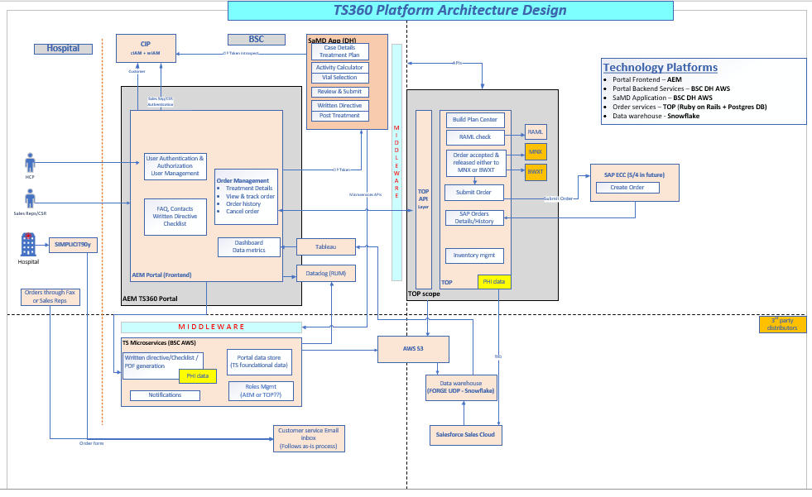

TO-DO
- Update diagram to reflect token introspection between CIP and SaMD app.
- Update token introspection between CIP and API Gateway.
- Update how CIAM and WIAM works within CIP.
- Assumption CIAM and WIAM login redirects will be managed within CIP.
- Update how customer data and draft orders are saved.

AEM Application Architecture

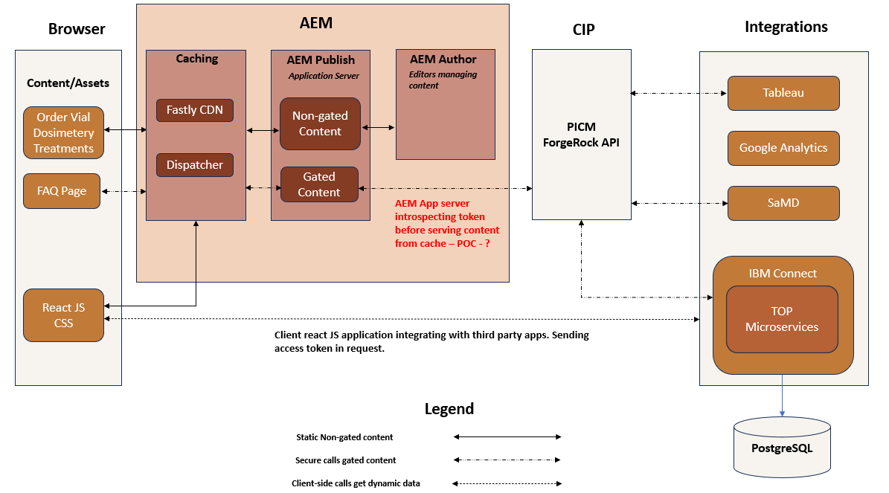

Application Architecture Overview
The above diagram depicts application architecture for TheraSphere360 app with respect to AEM. This architecture represents three flows – Gated Content Flow, non-gated content flow and client-side interactions with external integrations. Kindly refer legend in the diagram to understand flow of each architecture representation. Detailed explanation is mentioned below.
Static non-gated content Flow
For non-gated content, request for pages like (order a vial, calculate a dose, etc.) is made from browser. The request initially checks Fastly CDN cache. If the content is present in CDN cache, then page is served back to browser without even reaching AEM. Usually, first request to a page is never available in CDN.
If the CDN does not holds copy of the page, the request goes to AEM’s caching system named(dispatcher), if the page is available in dispatcher cache the page is served. During first request, page is never available in dispatcher cache. Only subsequent requests are cached in dispatcher.
If the page is not available in dispatcher cache, the request reaches out to AEM publisher which acts like app server. It processes the request and prepare the html of the page by processing the page component and other available components in the page (Ex: Header, footer, form component etc.). Once the page is prepared, html of the page is served back and cached in dispatcher and CDN cache both.

The browser reaches out to AEM and follow similar process to get react JS/CSS files from AEM server.

AEM author plays important role in managing the content of the pages. Editors of site logs into AEM author instance to drag and drop components (like header, footer) to define the content of the page. Once the page is ready, they simply publish the page and content is replicated to AEM publish instance. AEM author instance is accessible only to BSC employees who have been authorized to update Therasphere content.

Once the non-gated static page is loaded, the react JS reaches to third party system by making ajax calls. Below is the brief overview of each integration.
- SAMD app will be hosted on a separate DHP AWS, user will be redirect to SaMD app upon Tratreat selection, secure session data will be passed using API calls via API GAteway. SaMD app performs token introspection by making API calls to CIP.
- Google analytics events are triggered by ReactJS to directly integrate with Google Analytics.
- All the API calls are made from react JS in browser, API gateway accepts access token and serve the secure data only after validating the token authenticity and authorization.
- ReactJS loads the Tableau screen in Iframe or makes ajax calls to get secure data by passing access token in API calls. Tableau app performs token introspection by make API calls to CIP.

Static gated content Flow
For gated content, request for pages like (FAQs, resource pages, etc.) is made from browser. gated content pages are never served from CDN cache. Such pages are marked private and has CDN max age set to 0.

Such content pages can be served from dispatcher cache. However, before serving page from cache, system validates the token authenticity. For token authenticity, the calls go to publisher which picks up the token from cookie and perform token introspection. If token is valid and authenticated, we serve the content either via publisher or dispatcher (if page is available in cache).

AEM cloud Internal Architecture
The list of high-level composable services in AEM as a Cloud Service can be represented with two segments - Content Management and Experience Delivery:

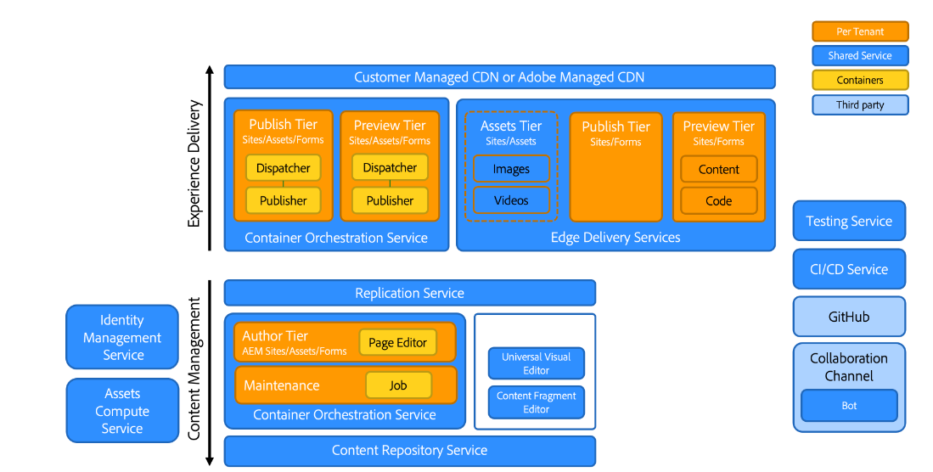

- The AEM Author tier (For content management):
Provides a web-based interface (with associated APIs) for the management of Web content. Headful Pages are managed via the Page editor and the Universal Editor.

- The AEM Publish tier (For experience delivery):
- Runs a farm of standard AEM publishers and dispatchers, allowing for the dynamic rendering of web pages and API content (for example, Graph QL) assembled with published content.
- Is primarily based on server-side application logic.
There are also the key adjacent services:
- The Assets tier:
- Allows for the delivery of approved and published media items from AEM Assets. For example, images, and videos.
- The media items are usually referenced from experiences running on the AEM publish tier, or the Edge Delivery publish tier, or from any other Adobe Experience Cloud application integrated with AEM Assets.

- The AEM Preview tier and the Edge Delivery Services Preview tier:
- Are also available for experiences built with the AEM Publish tier or the Edge Delivery publish tier respectively.
- Allows content authors to preview content in-context before publish operations.
- The Replication Service:
- Situated in between the content management tier and the experience delivery tier.
- Is responsible for processing the publish operations issued by content authors, then providing the published content to the publish tiers (AEM).

- The Content Repository service:
- Is used by the AEM author tier.
- Is a cloud-based instance of a JCR-compliant content repository, implemented by the Apache Oak technology.
- The persistence of content is primarily based on blob-based cloud storage.

- The CI/CD service:
Represents the subset of Cloud Manager functionalities dedicated to managing deployment pipelines to the AEM environments.

- The Testing service:
Represents the underlying infrastructure used to execute the below tests as part of a deployment pipeline to an AEM environment, or as part of a GitHub pull request to an Edge Delivery code repository.
- functional tests
- UI tests: for example, based on Selenium or Cypress scripts.
- experience audit tests: for example, Lighthouse scores

- The Data service:
- Is responsible for exposing customer data such as licensing metrics (for example, Content Requests, Storage, Users) or usage reports (such as the number of uploads, downloads).
- The customer data can be exposed via APIs, and within product user interfaces (such as the Cloud Manager).

Securing API

AEM - API Gateway (TOP/Microservices) – CIP Sequence Diagram
This sequence diagram explains the flow of redirecting users to CIP login pages if user is not logged in and how API gateway introspects access token before returning any API response.

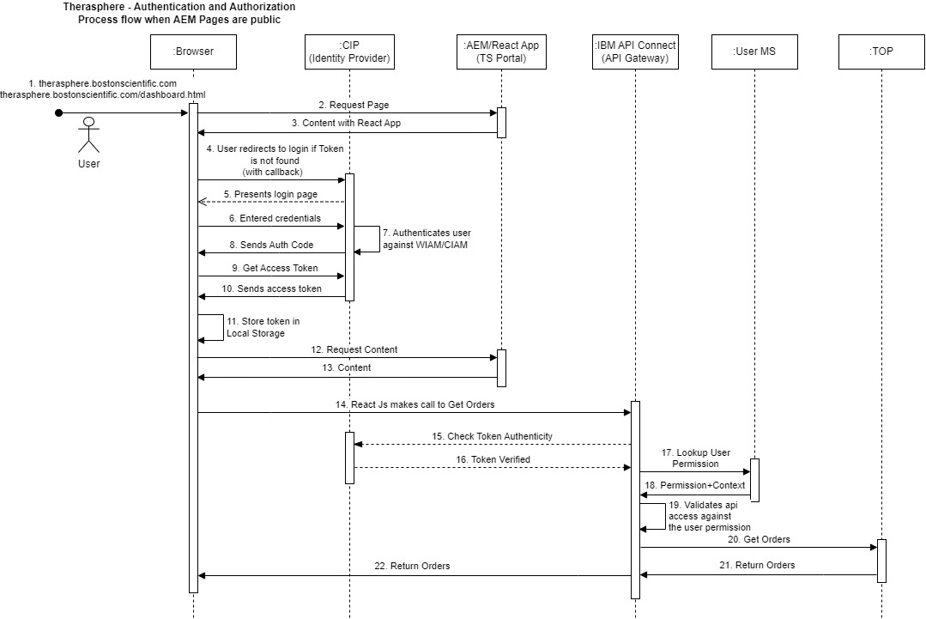

SaMD Application

<<SaMD team to update with required technical details>>
Refer to this SaMD Architecture Document:
97173192 Calculator Device Software Architecture.docx (sharepoint.com)

AEM - SaMD Integration
This section describes integration of TS360 portal with the SaMD application. SaMD application will be integrated with the portal for the following functionalities.
- Create Treatment Draft
- Edit Treatment Draft
- View Documents

AEM portal will redirect user to the SaMD application for the above functionalities, and user will be authenticated in SaMD if not already logged in. AEM (Non-SaMD) and SaMD will maintain separate login sessions having different client applications created in CIP.

Please note- All the redirects from AEM (Non-SaMD) to the SaMD application will be routed through AEM CDN for keeping the URL same for SaMD and Non-SaMD links.

The below sequence diagram explains how the user is redirected from TS360 portal to the SaMD application.

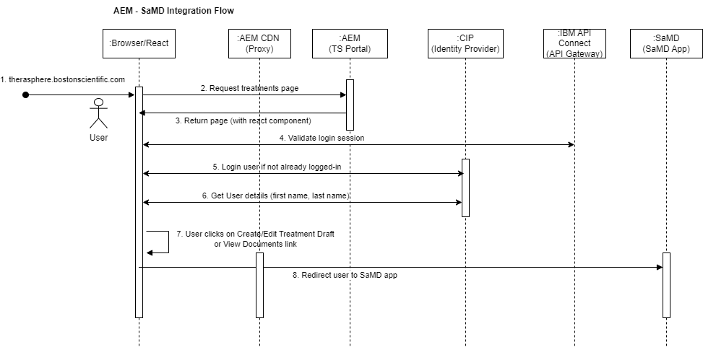

- User opens TS360 portal.
- Access Treatments page from left navigation.
- The treatments page will be loaded on browser.
- Platform JavaScript function will validate the user login session by calling session check Gateway API.
- User will be authenticated using CIP, if no valid login session.
- Get user details (first name & last name) from CIP.
- User clicks on create/edit treatment draft or view documents link.
- User will be redirected to the SaMD application through AEM CDN proxy.

AEM - CIP (Customer Identity Portal) Integration
This section describes integration of TS360 portal with the CIP. CIP will be used for the user authentication in the portal. TS360 portal will have a separate client application created in CIP.

The login flow will be triggered when user accessing a page on the portal. The portal will maintain a valid login session until user is actively browsing, and session is terminated when user is inactive for an hour or when user forcefully logs out.

Platform built JavaScript code is hosted on the AEM server to manage user login session, and TS360 portal react application will call the required JavaScript function to perform the below actions.
1. Initiate Login
2. Refresh Token (Renew login session)
3. Logout (Terminate login session)

Initiate Login Flow:
The below sequence diagram explains how the user login flow works in TS360 portal.

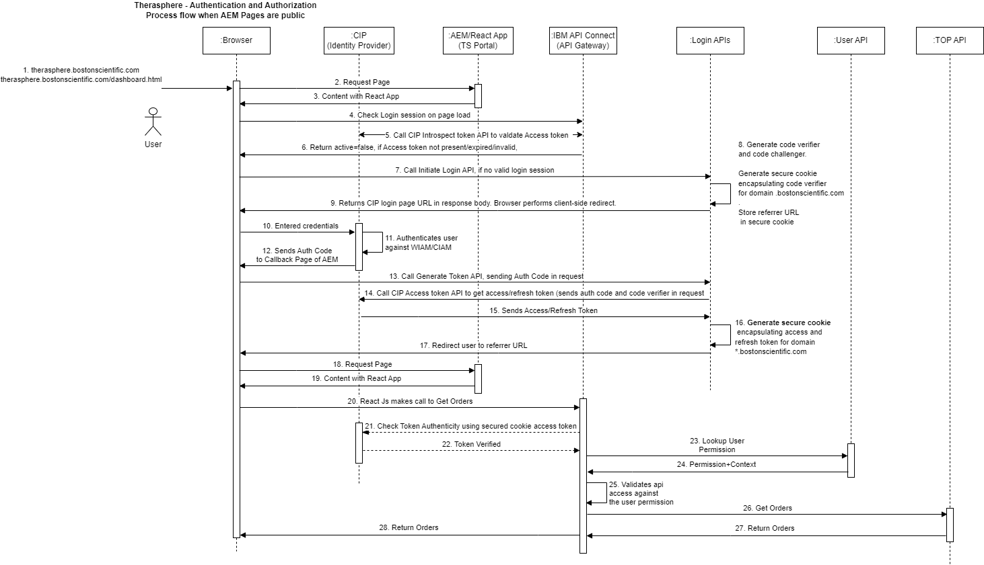

- User opens a new browser session.
- Request a page on TS360 portal (hosted on AEM server).
- React app loads in the browser through requested page (React code is hosted on AEM server)
- The react app will invoke platform JavaScript function, that in turn calls the API Gateway to validate the login session.
Please note- user requires a valid login session to access any page in TS360 portal,
- API Gateway will in turn call the CIP introspection API to check the login status.
- API Gateway will return the login status (true or false) to the platform JavaScript function. If user has a valid login session, then it returns true; otherwise, false.
- If login status is false, platform JavaScript function will add original referrer URL in the browser session storage, then call the Initiate login API.
Please note- referrer URL will be used to redirect user after login is successful.
- Initiate login API will generate a code challenge and code verifier. The code verifier will be stored in a secure cookie. Cookies are set with two flags i.e. isSecure(True) and HTTPOnly(True) for the code verifier, and it will be used to request Access Token in later steps. Then CIP Login URL will be created using “client_id”, “code_challenge”, “redirect_uri”, “scope”, etc.
Please note- code verifier cookie is set from the server side using HTTPOnly flag to avoid XSS issues.
- Initiate login API will return the CIP Login page URL to the platform JavaScript function.
- Platform JavaScript function redirects user to the CIP Login page. The user will enter the credentials.
- CIP validates the user credentials.
- If user credentials are valid, the CIP appends an authorization code to the callback page url (redirect_uri), which was sent as part of the login URL.
- Platform JavaScript function (attached with callback page) will call Generate token API to get an access token, by sending authorization code and code verifier (browser cookie).
- Generate token API will in turn call the CIP Access token API to exchange the authorization code for an access token, appending the code verifier to the request.
- CIP verifies the authorization code and returns access token and a refresh token to the generate token API.
- Generate token API creates access token and refresh token as secure cookies (HTTPOnly) in parent domain, so that these cookies can be read from specific domain or subdomains only.
Please note- Access token and refresh token are set from server side using HTTPOnly flag to avoid XSS issues.
- Generate token API returns success response to the platform JavaScript function. Platform JavaScript function will redirect user to the original referrer URL by fetching it from the session storage.
Please note- Original referrer URL was set in step#7.
- Request a page with valid login session.
- Requested page will be loaded from AEM.
Please note- Session check happens on every page load using platform JavaScript code (Same as step 4), but it returns 200 okay for the subsequent requests having valid login session.

Get Data after Login:
- React app will make API call to get the data (Ex. orders from TOP).
- API Gateway will in turn call the CIP introspection API to check the validity of the access token (from secure cookie)
- CIP validates the token and responds status as “true” or “false”. If token is valid then it returns true; otherwise, false.
- If the token is VALID, the API Gateway will make another call to User permission API to get the user permissions for accessing protected resource from the resource server (TOP/MDDS).
- User permission API will return the user permissions.
- API Gateway will validate the user permissions.
- If the authorization is SUCCESS, the API Gateway will forward the request to the resource server (TOP/MDDS). Otherwise, API Gateway will return 403 error to the react app.
- Resource server (TOP/MDDS) will return the response to the API Gateway.
- API Gateway will return the response to the react app.

Refresh Login Session:
The access token is valid for 1 hour, and it will be automatically refreshed when user actively browsing on the portal.

Logout Session:
The login session will be terminated when the user is inactive for an hour or user forcefully logs out using Logout option displayed in My Account fly-out menu in header.

AEM - Tableau Integration (Data)
This section describes integration of TS360 portal with the Tableau application. Tableau creates separate connected apps for the internal and external user metric dashboards. TS360 portal will display fully integrated tableau report for the logged-in user.

The below sequence diagram explains how the user login flow works in TS360 portal.

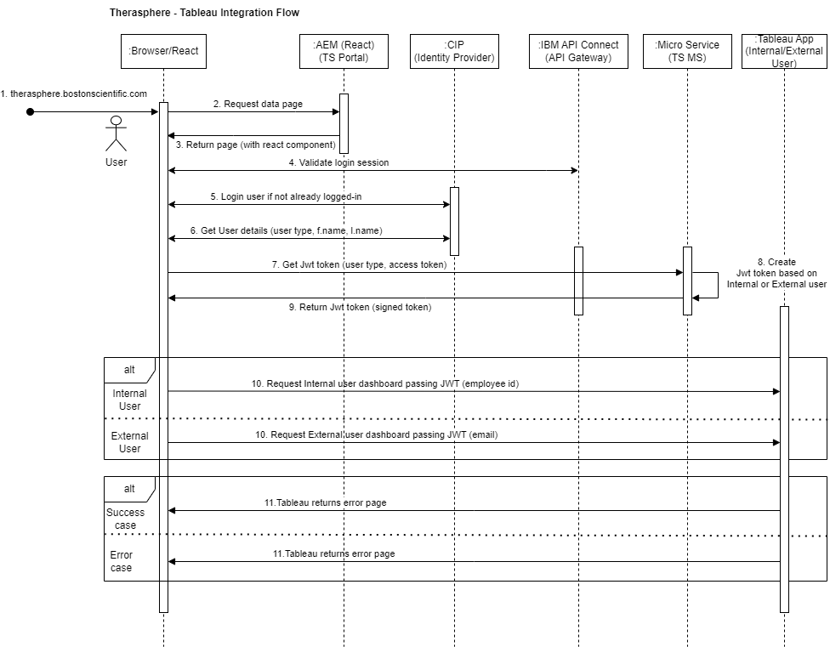

- User opens TS360 portal on a new browser session
- Access data page on the portal.
- The portal react app and platform JavaScript will be loaded in the browser as part of page response (React/JS code is hosted on AEM server).
- The platform JavaScript function will validate the login session by calling session check Gateway API.
- User will be authenticated using CIP, if no valid login session.
- Platform JavaScript function will call user details API and get the user details from CIP, then user first name, last name and user type will be stored in the redux store at browser side.
- The portal react app will call JWT token API by passing user type and access token in the request, then JWT token will be generated based on the user type (Internal or External) and returned to the client side.
- The portal react app will use Tableau react component on the data page to make a GET call to the Tableau connected app.
- Tableau verifies the trust relationship with the portal by identifying the connected app
and shared secrets used in the JWT. Then Tableau creates a session for the user.
- Tableau returns data; If valid JWT token and user is authenticated in Tableau.
- Tableau returns error; If not a valid JWT token or user is unauthorized to access the data.

AEM - Resource Module (Contact US/FAQ Pages)
This section describes resource module whic is hosted on AEM server. The resource module pages will be created using AEM web platform components outside of AEM SPA. The UX design for these pages should match with AEM web platform components.

Architectural Goals and constraints
List the goals of the architectural. Describe the principles and guidelines governing the architecture and evolution over time. Describe key assumptions at the architectural level. Define any special constraints that may apply: design and implementation strategy, development tools, team structure, schedule, legacy code, etc.

Use case View
Provide application-level behavioral use cases. Its intent is to summarize the detailed functional requirements and visualize the top-level functional capabilities. Business rules (i.e., special system-level assumptions and constraints) for the whole system or for each individual use case are also described in this section. This view spans all the other views and is central to the architecture.
Relationship of hardware, software and the physical environment should be illustrated in this view with appropriate tools, e.g., context diagram. Description of the hardware to be used, any supporting software used (e.g., operating systems, drivers, other applications), the communication links (links among the internal items, supporting software, hardware, user, etc), and the interface definitions between software and external components, should be included in this section.

Software Of Unknown Provenance (SOUP) Usage
Identify Software of Unknown Provenance (SOUP) to be used in the system and how it interacts with developed software.

Logical View
Show the top-level static and dynamic views of the system. Describe the high-level logical grouping and interactions of the functionalities using component, class/package and collaboration diagrams, and description of how these logical design entities fulfill the use cases. Avoid depicting detailed design.
This section should effectively cover the following topics:
- The decomposition of the software system into software items and the interfaces between the items at a high level.
- Hierarchical structure of software items, functional responsibility of these items, and the manner in which these items interact from the architecture perspective,
- Identify hazardous situations from a software perspective and the ability of the architecture to mitigate hazards, avoiding any detailed design information.

Process View
Describe the system's decomposition into lightweight processes (single threads of control) and heavyweight processes (groupings of lightweight processes). Organize the section by groups of processes that communicate or interact. Describe the main modes of communication between processes, such as message passing, interrupts, and rendezvous. Describe the rationale of the execution concurrency and how it addressed the performance concerns of the use cases.

Deployment View
(Describe how the physical software items are deployed on the hardware platform and how each independent logical execution flow is mapped to a physical OS process or a thread.)

AEM Code Branching & Deployment
Deployment strategy for the Thera Sphere site code deployment will follow the same as all other BSC sites hosted on AEM Cloud. Adobe cloud service rolling deployment slowly replaces instances of the previous version of an application with instances of the new version of the application with no downtime. For any rollback needs, we can either deploy the code from previous successful release or Adobe support team can deploy the backup version from the last successful deployment.

Code Propagation Path

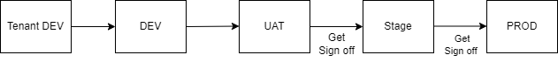
- DEV/UAT deployments are automated through CI/CD pipelines.
- Stage and production deployments are manual/controlled deployments based on sign off and business approval.
- Tenant dev is a separate environment as new applications won’t be merged in stage and prod environment until it’s built ready. Tenant environment gives flexibility to other tenant teams to continue build stories under every sprint and deploy changes to dev, stage, and prod environments.
  - As Therasphere is new app, we will build and validate everything in tenant dev and once ready, we will move everything to other environments.
  - If the tenant environment is not available, we will impact developers’ productivity where developers will spend efforts in removing unwanted tenant code from dev branch in every sprint, increases co-ordination effort with other teams and this will result in more chances of error for all tenants.
  - With AEM cloud migration going on, a new tenant is must to avoid impact to tenant performing AEM cloud migration.

Deployment Pipelines
This section covers different pipelines used for the PR checks and code deployment to each AEM environment.

PR Checks Pipeline

DEV Deployment Pipeline

UAT Deployment Pipeline

Stage Deployment Pipeline

PROD Deployment Pipeline

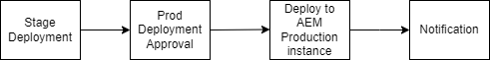

Pipeline Stages
- Dependencies- download dependencies before starting build process.
- Lint- linting tool will analyze source code to detect potential errors, security vulnerabilities, or coding style issues.
- Unit Tests- unit test cases will be executed to test and determine if the code works as intended.
- Sonar- sonar scan will run on Sonar cloud and Adobe cloud manager.
- Build- build the code, if build fails then send a notification in the Teams channel and an email will be sent to the concerned team/person.
- Deploy- code will be deployed on AEM server.
- Approval- approval is needed from deployment lead to deploy the code on production environment.
- Security & Load Test- security and load testing will be done after stage deployment.
- Notification- notification will be sent in case of success or failure of build.

Branching
AEM Cloud Environments and Branches:
The below table captures BSC AEM environments and mapping branches for the code deployment.
Environment | Bitbucket Branch | Adobe Cloud Manager Branch
DEV | dev | dev
UAT | dev | uat
STAGE | Release-NNNN | master
PROD | Release-NNNN | master
Tenant DEV | <tenentdev> | <tenentdev>

Branching Strategy:
Deployment strategy for the Thera Sphere site code deployment will follow the same as all other BSC sites hosted on AEM Cloud. The below diagram depicts the branching strategy used for deploying code to different AEM environments.
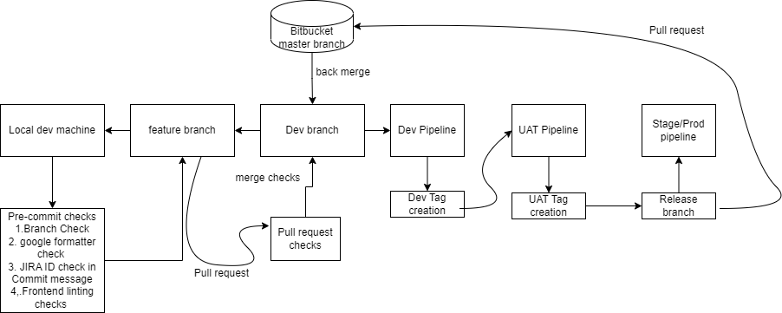

Implementation View
Expand upon the Logical view and divide the logical entities into physical software items such as shared libraries, configuration files, etc. Group them into multiple layers. Include a component diagram that shows the relationship between layers. Provide explanations of how the physical architecture addresses the business rules and/or system constraints. Keep in mind this is at the architecture level so any entities define should not be detailed design.

Data View

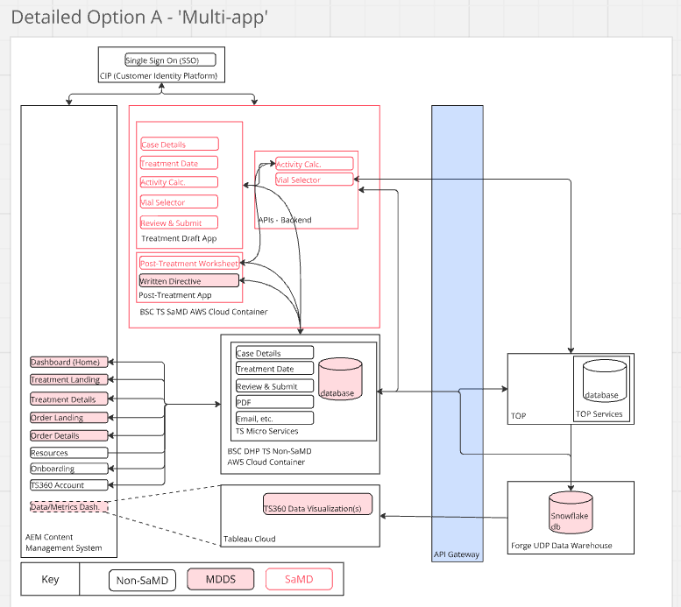

Design Constraints
Design constraints are mid-level design decisions driven by the design criteria. They are to be followed during the detailed design and code development.
Design constraints are used to evaluate the software design and implementation against the design criteria. Conformance to the design criteria is shown by conformance to each design constraint.
List each design constraint imposed on the software.

Security Architecture
The TheraSphere 360 digital platform’s web-based front-end application is hosted in Boston Scientific’s Adobe Experience Manager Cloud environment. All connections inbound and outbound to the application are controlled via an Ingress controller that requires HTTPS / TLS 1.2 or higher. Any non-secure connections are automatically redirected to a HTTPS secured connection.
- The TheraSphere 360 digital platform’s back-end API is also hosted in Boston Scientific’s AWS EKS environment. All connections inbound and outbound to the application are controlled via an Ingress controller that requires HTTPS / TLS 1.2 or higher. Any non-secure connections are automatically redirected to a HTTPS secured connection.
- Boston Scientific’s AWS EKS environment is a Boston Scientific managed and controlled AWS EKS instance. The Radioembolization Activity Calculator is deployed to a private namespace within the cluster controlled via Boston Scientific’s SSO solution and Active Directory group membership. All access to the namespace in the cluster requires approval by the Active Directory group owner.
- The TheraSphere 360 digital platform’s front-end and back-end applications are containerized independently, and controlled images are stored in a private Gitlab Container Registry.
- The AWS EKS environment is configured for read only access to the container registry to be able to pull container images from the private registry and run them in the AWS EKS environment. The Gitlab environment is also controlled via Boston Scientific’s SSO solution. Owners of the Gitlab group can control group membership for new engineering team members.
- The API Gateway controls who can access (read and write to MDDS).
- The CIP platform controls system Authentication and some role-based controls.

Security Controls

Security Controls include, but are not limited to the following categories:
- Cryptography
  - All data is encrypted in transit (HTTPS/TLS 1.2+)
  - All data is encrypted at rest.
- Authentication
  - 1. CIP shall provide the ability to set password expiration intervals
  - 2. CIP shall enable the multi-factor authentication.
- Authorization
  - Role-based access
  - Principle of least privilege
  - Portal will introspect the login token, if no valid token found then redirect the user to the CIP login page for authentication.If the token introspection affirms that token is valid then the user will be able to see secure pages.
- Integrity
Within AEM, cross site scripting can be handled in two ways.
  - 1. As best practice, developer needs to mention the context of content that is visible on the page. For ex: A link should be attached to a context URL, so that AEM can ensure that content only contains URL pattern instead of any insecure JS.
  - 2. As a best practice, developer needs to ensure any data returned from backend (Java) is validated or filtered using apache XSSAPI.
- 3. Web Sever security headers will be configured to protect agains
- t system/sensitive Information disclosure and XSS/CORS issues.
- Event Detection and Logging
  - AEM will log activities related to local introspection for users accessing secure pages.
- Resiliency and Recovery
  - The system shall have a required uptime of 99.9%.
- Security Misconfiguration -
Portal will be hosted on AEM cloud infrastructure which is managed by Adobe. AEM ships with integrated Security Health checks that help you monitor security configuration at a glance. AEM provides security operations dashboard which highlights if AEM is facing any security issue. Additionally, before any code deployment AEMaaCS runs a security scans which checks all system misconfiguration.

Security Architecture Views
In Progress:

Appendices
Appendices may be used to provide information published separately for convenience in document maintenance (e.g., charts, classified data). As applicable, reference each appendix in the main body of the document where the data would normally have been provided. Appendices may be bound as separate documents for ease in handling. Appendices must be lettered alphabetically (A, B, etc.).

